**Course: C339 Data Fundamentals**

**Date: February 20, 2023**

**Title: Data Modelling**

**Entity Relationship Diagrams (ERD) Symbols & Notations**

* ERDs are flowcharts or graphical approaches that illustrates how different entities relate to each other. It is a standard way of modeling databases and business processes.
* An ERD consists of three basic elements: entity, relationship, and attribute.
* Along with these are more components based on their main elements: weak entity, multi-valued attribute, and many more.
* Other notations used to make ERD diagram examples include cardinality and ordinality to define relationships in numbers.

| Entity | Represents the name of an object, person, thing, event, or place where data is stored. This is usually represented by rectangles. |
| --- | --- |
| Weak entity | An entity that solely depends on the existence of another entity. |
| Attribute | Refers to the unique characteristic/property of an entity. |
| Multivalued attribute | Refers to an attribute that can have multiple values. |
| Derived attribute | Refers to an attribute that can be derived from other other attribute. Usually illustrated as a dotted oval. |
| Relationship | Defines the interaction between two entities. |
| Cardinality | Refers to the occurrences of a relationship. Particularly, it specifies the maximum number of relationships between two entities. |
| Ordinality | Describes whether a relationship is mandatory or optional. Also used to determine the absolute minimum number of relationships. |

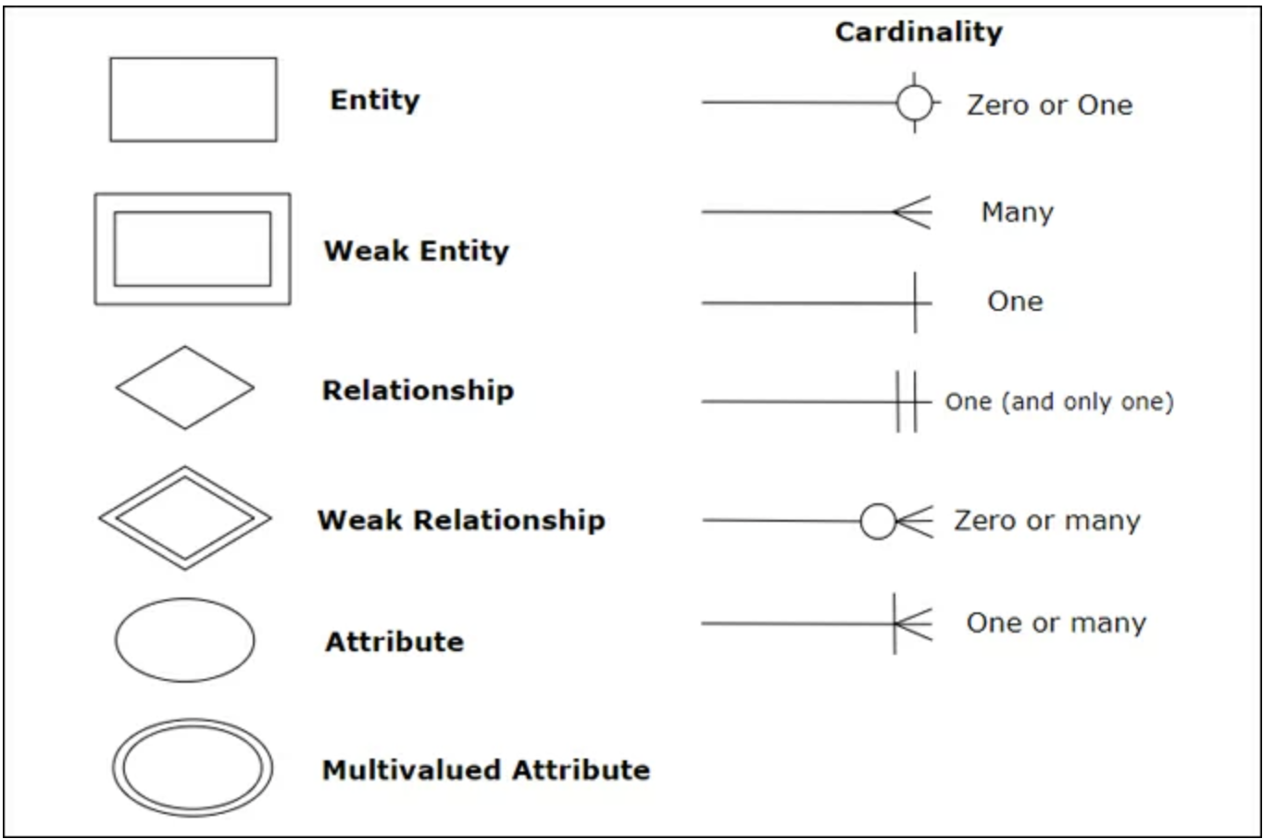

**Case Study/Application**

Example 1 - ERD of customers, products, and orders.

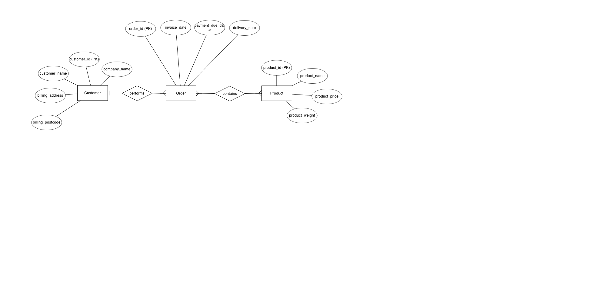

Abbreviations: ERD: Entity Relationship Diagram, PK: Primary key

Example 2 - ERD of doctors, specialisations, and patients.

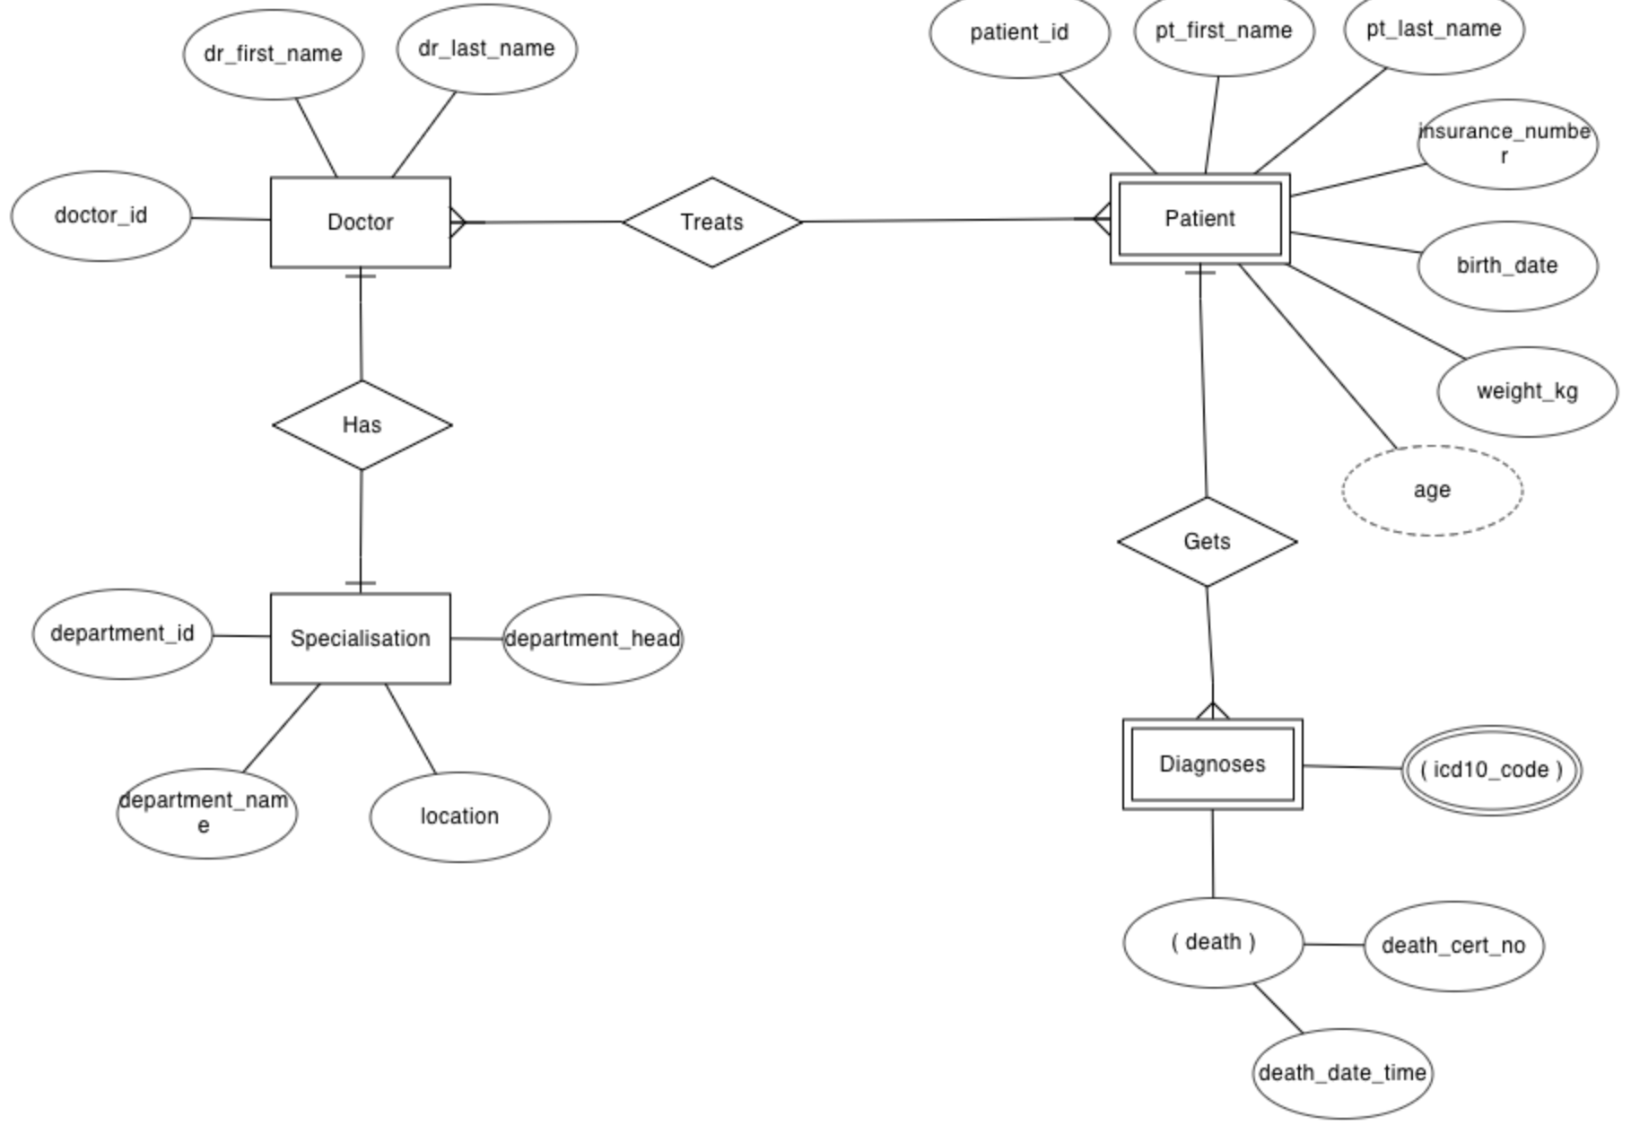

**Reduction of ERDs to tables**

The database can be represented using the notations, and these notations can be reduced to a collection of tables. In the database, every entity set or relationship set can be represented in tabular form. There are some points for converting the ER diagram to the table:

1. Entity type becomes a table.
   * In Example 1, Customer, Order, and Product forms individual tables.
   * In Example 2, Doctor, Specialisation, Patient, and Diagnoses form individual tables.
2. All single-valued attributes become a column for the table.
   * In Example 1, customer_id, company_name, customer_name, billing_address, billing_postcode forms columns of the Customer table.
   * In Example 2, doctor_id, dr_first_name, and dr_last_name forms columns of the Doctor table.
3. A key attribute of the entity type represented by the primary key.
   * In Example 1, customer_id, order_id, and product_id are the key attributes of the entity.
   * In Example 2, doctor_id, department_id, patient_id are the key attributes of the entity.
4. The multivalued attribute is represented by a separate table.
   * In the diagnoses table (Example 2), icd10_code is a multivalued attribute. Therefore, it is not possible to represent multiple values in a single column of the diagnoses table.
   * Hence, we create a table diagnoses_icd10 with column name patient_id and icd10_code. Using both columns, we create a composite key.
5. Composite attribute represented by components.
   * In the given ER diagram, student address is a composite attribute. It contains CITY, PIN, DOOR#, STREET, and STATE. In the STUDENT table, these attributes can merge as an individual column.

Derived attributes are not considered in the table.